**✨ Understanding the New Testament: Fresh Paths into Ancient Truths**

**Ryefield Books For Churches | July 2025 Edition**

The New Testament remains the beating heart of Christian faith — 27 books written in the wake of Jesus’s life, death, and resurrection, proclaiming a new covenant and a radical hope for all people.

At Ryefield Books For Churches, we believe in providing access to books that help deepen understanding of Scripture, theology, and Christian living. Whether you're studying the Gospels for the first time, leading a small group, or digging into Greek vocabulary, here’s a curated collection that brings the New Testament into fresh and focused light.

**📖 Straight from the Gospels**

Short, accessible, and ideal for outreach or devotional reading.

* **NIV Gospel of Mark** – ISBN 9781444702866

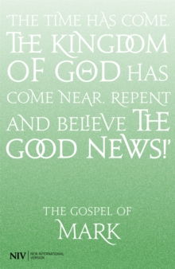

<https://www.ryefieldbooks.com/books/niv-gospel-of-mark/9781444702866>

* **NIV Gospel of John** – ISBN 9781444702880

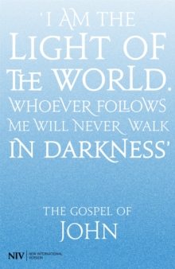

<https://www.ryefieldbooks.com/books/niv-gospel-of-john/9781444702880>

* **NIV Gospel of Luke** – ISBN 9781444702873



<https://www.ryefieldbooks.com/books/niv-gospel-of-luke/9781444702873>

*Beautifully printed standalone editions—perfect for personal reflection or church giveaways.*

**🕊️ Devotional Living in the Light of Scripture**

* **The Whole Story: A 52-Week Devotional Journey Through Every Book of the Bible** – Dr. David Jeremiah | ISBN 9781400230525  
  *A panoramic, devotional walk through the Bible, helping readers see Christ in every book.*

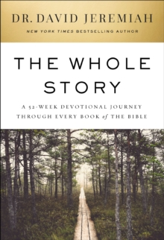

<https://www.ryefieldbooks.com/books/whole-story/9781400230525>

* **Loyal in His Love** – Tabitha Panariso | ISBN 9780310160205  
  *A tender invitation to trust Jesus deeply, especially in seasons of relational disappointment.*



<https://www.ryefieldbooks.com/books/loyal-in-his-love/9780310160205>

**🧠 Theological Depth & Insight from Trusted Voices**

* **How God Became King** – Tom Wright | ISBN 9780281061464  
  *Discover how the Gospels proclaim Jesus not just as saviour but as the inaugurated King.*

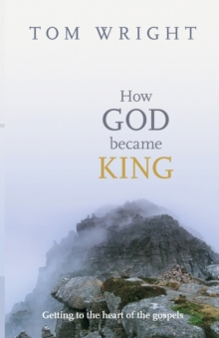

<https://www.ryefieldbooks.com/books/how-god-became-king/9780281061464>

* **The New Testament in Its World** – N.T. Wright | ISBN 9780281082711  
  *An academic yet accessible introduction to the history, theology, and literature of the early Church.*

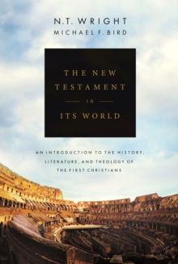

<https://www.ryefieldbooks.com/books/new-testament-in-its-world/9780281082711>

* **Paul: A Biography** – Tom Wright | ISBN 9780281078769  
  *A vivid, scholarly yet approachable life of Christianity's most prolific apostle.*



<https://www.ryefieldbooks.com/books/paul-a-biography/9780281078769>

* **Revelation for Everyone** – Tom Wright | ISBN 9780281072019  
  *A clear and hopeful guide to one of Scripture’s most misunderstood books.*

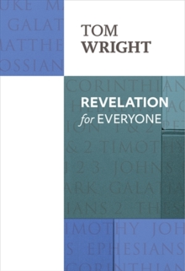

<https://www.ryefieldbooks.com/books/revelation-for-everyone/9780281072019>

* **Meeting God in Mark** – Rowan Williams | ISBN 9780281072507  
  *An elegant, spiritual reflection on Mark’s Gospel from the former Archbishop of Canterbury.*

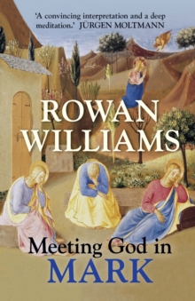

<https://www.ryefieldbooks.com/books/meeting-god-in-mark/9780281072507>

* **The Challenge of Acts** – Tom Wright | ISBN 9780281090587  
  *See how Acts challenges modern Christians to live empowered, Spirit-led lives.*

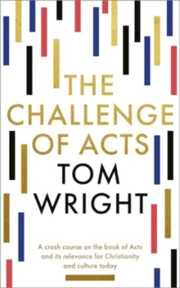

<https://www.ryefieldbooks.com/books/challenge-of-acts/9780281090587>

**🌍 Culture, Justice, and the Bible Today**

* **Immigration and Apocalypse** – Yii-Jan Lin | ISBN 9780300253184  
  *A provocative look at how Revelation has shaped U.S. attitudes toward immigration and identity.*



<https://www.ryefieldbooks.com/books/immigration-and-apocalypse/9780300253184>

* **The Widening of God’s Mercy** – Christopher B. Hays | ISBN 9780300273427  
  *Explores sexuality through the broad biblical story, with nuance, scholarship, and compassion.*

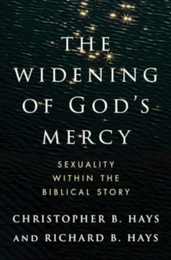

<https://www.ryefieldbooks.com/books/widening-of-gods-mercy/9780300273427>

**🛠️ Tools for Teachers & Preachers**

* **The Purple Basics** – Rice Broocks | ISBN 9780310086222  
  *A practical resource for grasping the Gospel message across the New Testament.*

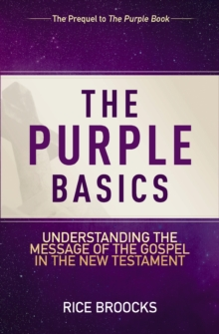

<https://www.ryefieldbooks.com/books/purple-basics/9780310086222>

* **Zondervan Compact Greek Lexicon** – Paul Norman Jackson | ISBN 9780310099499  
  *A vital, portable tool for anyone engaging with the New Testament in its original language.*

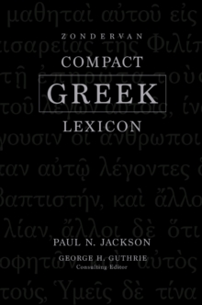

<https://www.ryefieldbooks.com/books/zondervan-compact-greek-lexicon/9780310099499>

**🛒 All titles are available for order now through the Ryefield Books website.**

📍 Based in Uxbridge, we’re here to support your church, ministry, or theological studies with trusted resources and expert service.

👉 Visit us: [www.ryefieldbooks.com](https://www.ryefieldbooks.com/)  
📬 Questions or bulk orders? Message us directly on LinkedIn or email [info@ryefieldbooks.com](mailto:info@ryefieldbooks.com)

**Stay rooted. Stay resourced. Stay inspired.**  
*Until next time from The Ryefield Books For Churches Team*